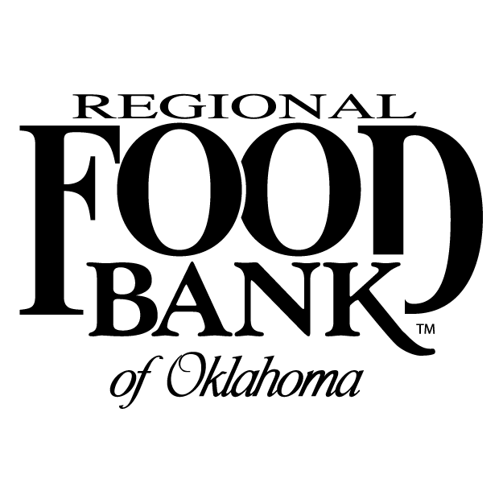
FOR IMMEDIATE RELEASE
Download Holiday Match assets.
It’s the Most Wonderful Match of the Year
Donations to the Regional Food Bank are Doubled up to $600,000 Thanks to Holiday Match
(OKLAHOMA CITY) – Nov. 14, 2019 - 'Tis the season to help our neighbors facing hunger. Through Dec. 31, all donations to the Regional Food Bank of Oklahoma are matched, up to $600,000, thanks to a gift from APMEX.com, Cresap Family Foundation and Chesapeake Energy Corporation.
During the Holiday Match campaign, every $1 donated helps the Regional Food Bank to provide eight meals to those living with food insecurity in central and western Oklahoma. Once the match is met, every $1 still helps to provide four meals.
“The Holiday Match Campaign is a great opportunity for Oklahomans to come together because your dollar will go further during this campaign and will help provide meals for families all across the state,” said Scott Thomas, president and founder of leading online Precious Metals Retailer APMEX.com. “This is APMEX’s fourth year in a row to partner with the Regional Food Bank to help support the Holiday Match effort and it really means a lot to us because at APMEX, giving back is a core value of ours that we take to heart.”
Oklahoma is the fifth hungriest state in the nation with one in six residents living with food insecurity. In the last year, the Regional Food Bank distributed more than 42.5 million meals through its community-based partner agencies.
“No one should ever have to worry where their next meal is coming from," said Katie Fitzgerald, chief executive officer of the Regional Food Bank. "We are so grateful to our sponsors for providing the match and helping Oklahomans double their impact in the fight against hunger this holiday season."
Together, we can solve hunger. To make a tax-deductible donation, please visit rfbo.org/give or call 405-600-3161. Donations may also be mailed to:
Regional Food Bank of Oklahoma
Holiday Match
P.O. Box 270968
Oklahoma City, OK, 73137-0968
About the Regional Food Bank of Oklahoma
The Regional Food Bank of Oklahoma is leading the fight against hunger in 53 counties in central and western Oklahoma and envisions a state where everyone, regardless of circumstance, has access to nutritious food. Founded in 1980, the Regional Food Bank is the state's largest hunger-relief 501(c)(3) nonprofit that distributes food through a network of community-based partner agencies and schools. The majority of people served by the Regional Food Bank are chronically hungry children, seniors living on fixed incomes and hardworking families struggling to make ends meet. The Regional Food Bank is a member of Feeding America, the nation’s network of food banks. To join the fight to end hunger, visit rfbo.org.
Contact: Cathy Nestlen, Director of Communications and Marketing Austin Prickett, Marketing Manager
Regional Food Bank of Oklahoma Regional Food Bank of Oklahoma
O: 405-604-7115 C: 405-850-5425 O: 405-604-7113 C: 405-426-0984
cnestlen@rfbo.org aprickett@rfbo.org
###

